Name: Aspeta Divakar

Trainer Name: Harshee Pitroda

Course Name: Python & Machine Learning

Date:30/05/2022

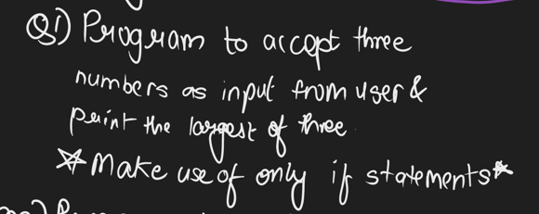

Code:

a=int(input('Enter first number:'))

b=int(input('Enter second number:'))

c=int(input('Enter third number:'))

if a>b and a>c:

print('a is largest')

if b>c:

print('b is largest')

if c>b:

print('c is largest')

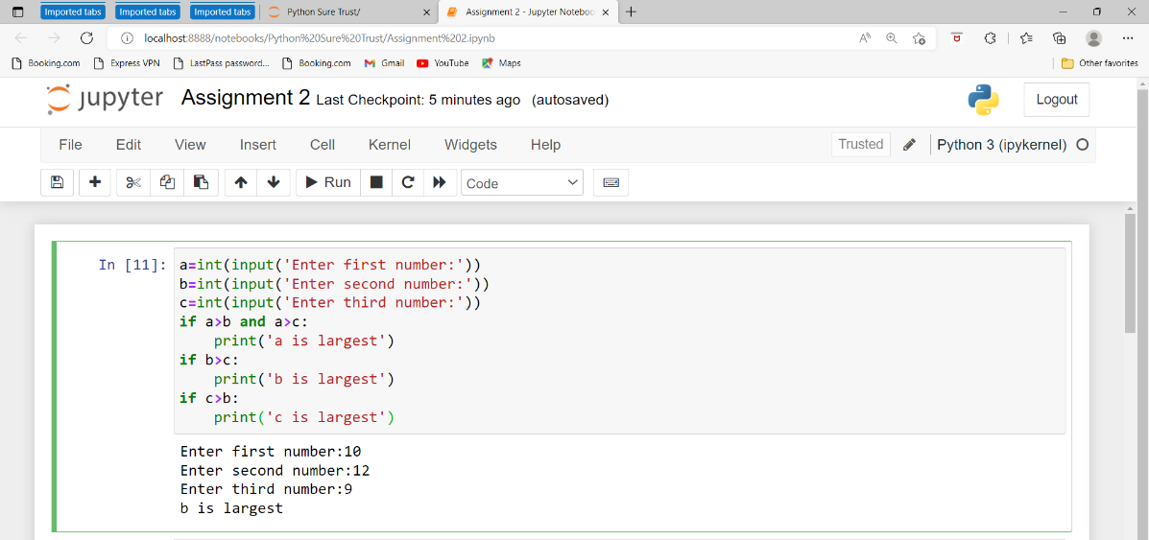

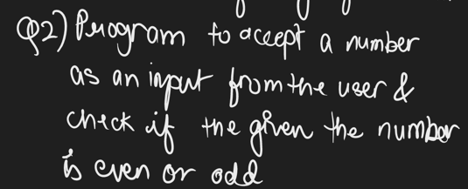

Code:

a=int(input('Enter a number:'))

Reminder=a%2

if Reminder==0:

print(a,"is an Even number")

else:

print(a,"is an odd number")

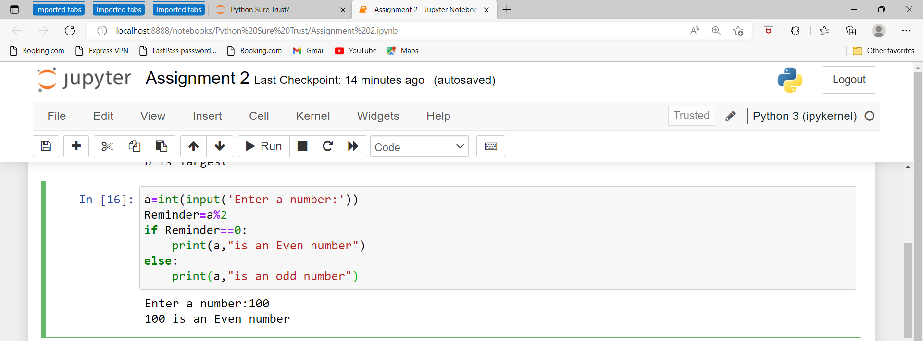

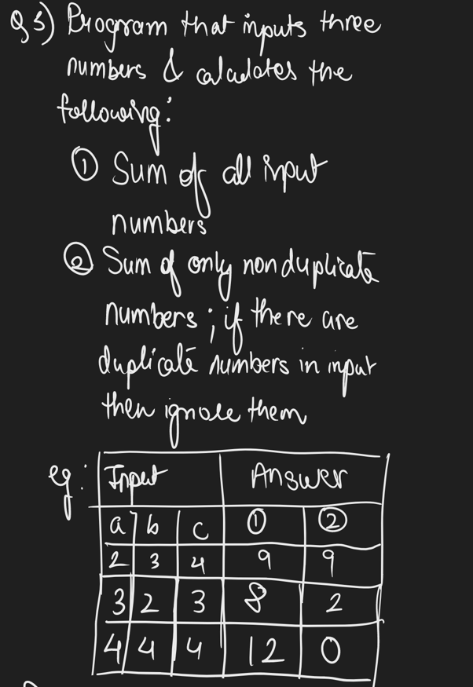

Code:

a=int(input('Enter first number:'))

b=int(input('Enter second number:'))

c=int(input('Enter third number:'))

print('sum is',a+b+c)

if a==b and a==c:

print('sum is 0')

elif b==a and b==c:

print('sum is 0')

elif c==a and c==b:

print('sum is 0')

elif a==b:

print('sum is ',c)

elif a==c:

print('sum is ',b)

elif b==c:

print('sum is ',a)

else :

print('sum is',a+b+c)

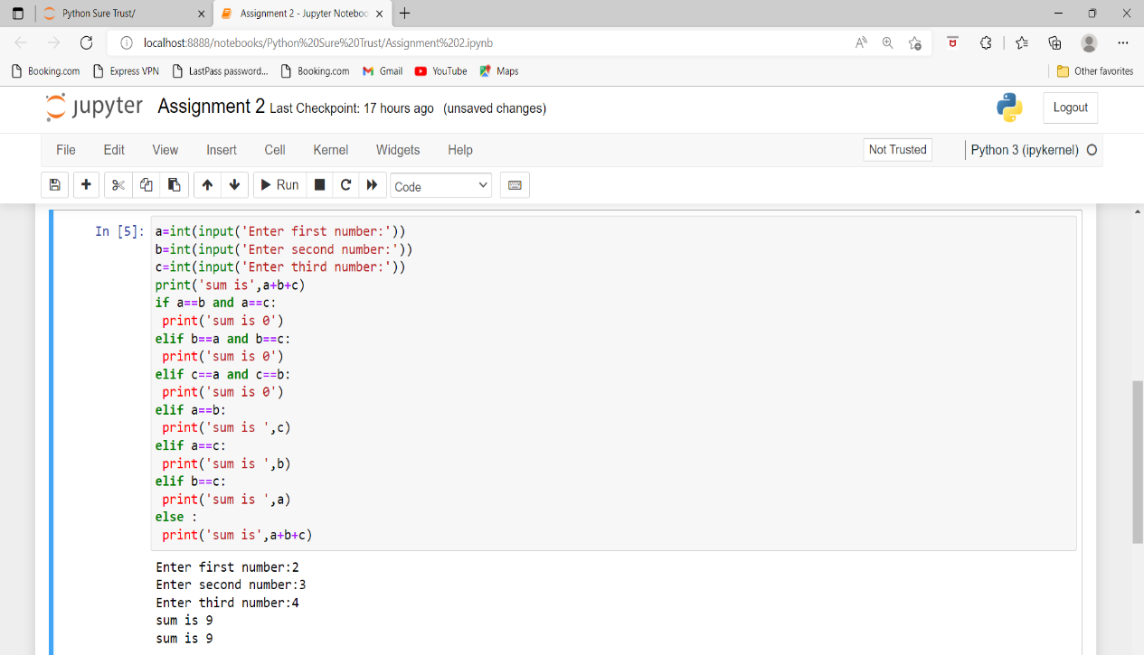

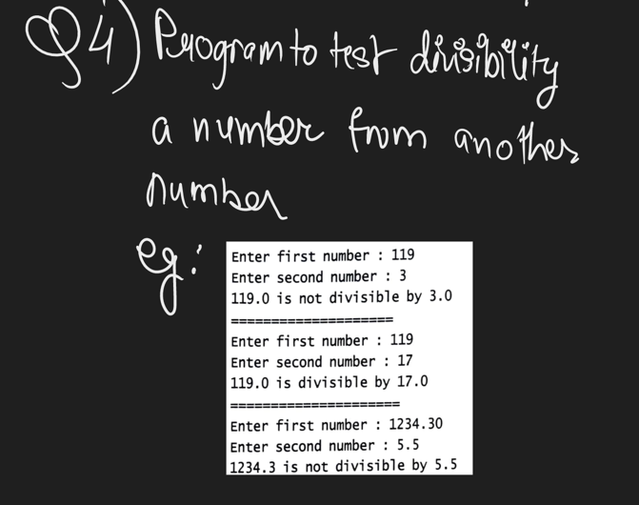

Code:

a=int(input("Enter first number:"))

b=int(input("Enter second number:"))

Reminder=a%b

if Reminder==0:

print(a,"is divisible by",b)

else:

print(a,"is not divisible by",b)

